Aircraft Systems and Instruments
Part – A (10X2=20 Marks)
- Name the three primary controls used in an air plane.
- Aileron – to provide rolling motion
- Elevator – to provide Pitch Up or Pitch Down motion
- Rudder – to provide Yawing motion
- What is the purpose of ‘auto pilot system’ installed in an air plane?
- To reduce the work strain and fatigue of controlling the aircraft during long flights.
- In the manual mode, the pilot selects each manoeuvre and makes small inputs into an autopilot controller.
- The autopilot system moves the control surfaces of the aircraft to perform the manoeuvre.
- In automatic mode, the pilot selects the attitude and direction desired for a flight segment. The autopilot then moves the control surfaces to attain and maintain these parameters
- What is the purpose of the ‘pressure Regulator’ in hydraulic system?
- Pressure regulators are pressurized by constant-delivery type pumps.
- One purpose of the pressure regulator is to manage the output of the pump to maintain system operating pressure within a predetermined range.
- The other purpose is to permit the pump to turn without resistance (termed unloading the pump) at times when pressure in the system is within normal operating range.
- What is the purpose of “Selector Valve” in hydraulic system?
  - Selector valves are used to control the direction of movement of an actuating unit.
  - A selector valve provides a pathway for the simultaneous flow of hydraulic fluid into and out of a connected actuating unit.
  - One port of the typical selector valve is connected with a system pressure line for the input of fluidpressure.
  - A second port of the valve is connected to a system return line for the return of fluid to thereservoir.
  - The ports of an actuating unit through which fluid enters and leaves the actuating unit areconnected by lines to other ports of the selector valve.

- State the purpose of ‘Dual magneto’ ignition in air craft piston engine.
The dual magneto incorporates two magnetos contained in a single housing. One rotating magnet and a cam are common to two sets of breaker points and coils. Two separate distributor units are mounted in the magneto. Many older single-row radial engine aircraft ignition systems employ a dual-magneto system, in which the right magneto supplies the electric spark for the front plugs in each cylinder, and the left magneto fires the rear plugs. Engines have old fashion but reliable fixed-timed dual magneto ignition systems.
- What is meant by ‘Hot Start’ in turbojet engine?
During engine start, the compressor is very inefficient, as already discussed. If the engine experiences more than the usual difficulty accelerating, the engine may spend a considerable time at very low RPM (sub-idle). Normal engine cooling flows will not be effective during sub-idle operation, and turbine temperatures may appear relatively high. This is known as a hot start .The AFM indicates acceptable time/temperature limits for EGT during a hot start. More recent, FADEC-controlled engines may incorporate auto-start logic to detect and manage a hot start.
- What is the function of the primary heat exchanger bypass valve in air cycle system?
- It acts similarly to the radiator in an automobile.
- To reduces the temperature of the air inside the system.
- State the major components in vapour cycle system (FREoN).
- Evaporator - The Freon boils in the evaporator at a temperature lower than the
Cabin Temperature. The result is that the Freon extracts heat from the cabin air
- Compressor - The compressor increases the pressure of the Freon in vapor form.
- Condenser - When heat is removed from the highpressure gas, Freon is
converted to aliquid
- Expansion valve - Lowers Freon pressure and, thus, Freon temperature
- Receiver
- Sub Cooler
- What is the function of ‘air Speed indicator’ as an aircraft instrument?
- The airspeed indicator is a sensitive, differential pressure gauge which measures and shows promptly the difference between pitot or impact pressure, and static pressure, the undisturbed atmospheric pressure at level flight.
- These two pressures will be equal when the airplane is parked on the ground in calm air.
- When the airplane moves through the air, the pressure on the pitot line becomes greater than the pressure in the static lines.
- This difference in pressure is registered by the airspeed pointer on the face of the instrument, which is calibrated in miles per hour, knots, or both
- State the importance of engine instruments.
- Engine instruments are those designed to measure operating parameters of the aircraft’s engine(s).
- These are usually quantity, pressure, and temperature indications. They also include measuring engine speed(s).
- The most common engine instruments are the fuel and oil quantity and pressure gauges, tachometers, and temperature gauges.

- a) Explain with the help of an aircraft sketch, the roles of primary and secondary flight controls of the aircraft.
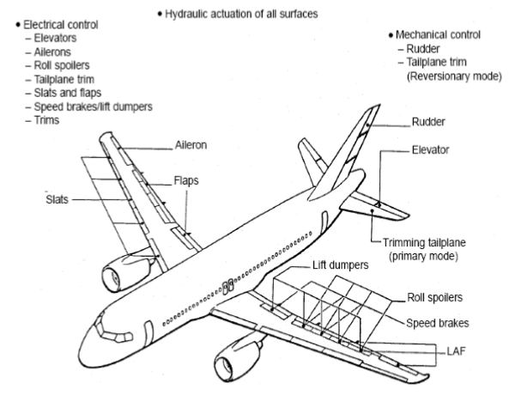
Ailerons:
    - Ailerons (French for "little wing") are control surfaces on each wing which control the aircraft about its longitudinal axis allowing the aircraft to "roll" or "bank"
    - This action results in the airplane turning in the direction of the roll/bank
    - With aileron deflection, there is asymmetrical lift (rolling moment) about the longitudinal axis and drag (adverse yaw)
    - They are located on the trailing (rear) edge of each wing near the outer tips
    - They extend from about the midpoint of each wing outward toward the tip, and move in opposite directions to create aerodynamic forces that cause the airplane to roll
    - The yoke manipulates the airfoil through a system of cables and pulleys and act in an opposing manor
    - Yoke "turns" left: left aileron rises, decreasing camber and angle of attack on the right wing which creates downward lift
    - At the same time, the right aileron lowers, increasing camber (curvature) and angle of attack which increases upward lift and causes the aircraft to turn left
    - Yoke "turns" right: right aileron rises decreasing camber and angle of attack on the right wing which creates downward lift
    - At the same time, the left aileron lowers, increasing camber and angle of attack on the left wing which creates upward lift and causes the aircraft to turn right

Rudder:
- Rudders are used to control the direction (left or right) of "yaw" about an airplane's vertical axis.
- Like the other primary control surfaces, the rudder is a movable surface hinged to a fixed surface that, in this case, is the vertical stabilizer, or fin Its action is very much like that of the elevators, except that it swings in a different plane - from side to side instead of up and downIt is not used to make the airplane turn, as is often erroneously believed
- In practice, both aileron and rudder control input are used together to turn an aircraft, the ailerons imparting roll
- Rudders are controlled by the pilot with his/her feet through a system of cables and pulleys:"Step" on the right rudder pedal: rudder moves right creating a yaw to the right"Step" on the left rudder pedal: rudder moves left creating a yaw to the left
- Elevators/Stabilators:
- Elevators and stabilators are both control surfaces which control the aircraft about its lateral axis allowing the aircraft to pitch
- Elevators are attached to the trailing edge of the horizontal stabilizer A stabilator is a combination of both the horizontal stabilizer and the elevator (the entire surface moves) Used to pitch the aircraft up and down by creating a load on the tail
- The elevators control the angle of attack of the wings:
    - The yoke manipulates the airfoil through a system of cables and pulleys: Yoke "pulls" back: elevator raises, creating downward lift, raising the nose, increasing the wing's angle of attack
    - Yoke "pushes" forward: elevator lowers creating upward lift, lowering the nose, decreasing the wing's angle of attack

Secondary Flight Controls consist of:
  - Flaps:
  - Trim surfaces
  - Spoilers/Speed brakes

Flaps:
  - Flaps allow for the varying of an airfoil's camber
  - Pitch behavior depends on the aircraft's flap type, wing position, and horizontal tail location
  - This produces a nose-down pitching moment; however, the change in tail load from the down-wash deflected by the flaps over the horizontal tail has a significant influence on the pitching moment
  - Flap deflection of up to 15° primarily produces lift with minimal drag
  - Deflection beyond 15° produces a large increase in drag
  - Drag from flap deflection is parasite drag, and as such is proportional to the square of the speed
  - Also, deflection beyond 15° produces a significant nose-up pitching moment in most high-wing airplanes because the resulting down-wash increases the airflow over the horizontal tail

Control Surface Tabs:
- Tabs are small, adjustable aerodynamic devices on the trailing edge of the control surface
- These movable surfaces reduce pressures on the controls
- Trim controls a neutral point, like balancing the aircraft on a pin with unsymmetrical weights
- This is done either by trim tabs (small movable surfaces on the control surface) or by moving the neutral position of the entire control surface all together
- These tabs may be installed on the ailerons, the rudder, and/or the elevator
Trim Tabs:
  - The force of the airflow striking the tab causes the main control surface to be deflected to a position that corrects the unbalanced condition of the aircraft
  - An aircraft properly trimmed will, when disturbed, try to return to its previous state due to aircraft stability
  - Trimming is a constant task required after any power setting, airspeed, altitude, or configuration change
  - Proper trimming decreases pilot workload allowing for attention to be diverted elsewhere, especially important for instrument flying
  - Trim tabs are controlled through a system of cables and pulleys
  - To learn more about how to use the trim tab in flight see the trimming the aircraft

Servo Tabs:
  - Servo tabs are similar to trim tabs in that they are small secondary controls which help reduce pilot workload by reducing forces
  - The defining difference however, is that these tabs operate automatically, independent of the pilot
Anti-servo:
- Also called an anti-balance tab, are tabs that move in the same direction as the control Surface
Servo:
- Tabs that move in the opposite direction as the control surface

(OR)
b) With the sketches, explain the function of the various configurations of the wing flaps.

Flaps:

Flaps allow for the varying of an airfoil's camber

Pitch behaviour depends on the aircraft's flap type, wing position, and horizontal tail location

This produces a nose-down pitching moment; however, the change in tail load from the down-wash deflected by the flaps over the horizontal tail has a significant influence on the pitching moment

Flap deflection of up to 15° primarily produces lift with minimal drag

Deflection beyond 15° produces a large increase in drag

Drag from flap deflection is parasite drag, and as such is proportional to the square of the speed

Also, deflection beyond 15° produces a significant nose-up pitching moment in most high-wing airplanes because the resulting down-wash increases the airflow over the horizontal tail

Trailing Edge Flaps:

Flap operation is used for landings and takeoffs, during which the airplane is in close proximity to the ground where the margin for error is small

With this information, the pilot must make a decision as to the degree of flap deflection and time of deflection based on runway and approach conditions relative to the wind conditions

The tendency to balloon up with initial flap deflection is because of lift increase, but the nose-down pitching moment tends to offset the balloon

A soft- or short-field landing requires minimal speed at touchdown

The flap deflection that results in minimal ground-speed, therefore, should be used.

If obstacle clearance is a factor, the flap deflection that results in the steepest angle of approach should be used

It should be noted, however, that the flap setting that gives the minimal speed at touchdown does not necessarily give the steepest angle of approach; however, maximum flap extension gives the steepest angle of approach and minimum speed at touchdown

Maximum flap extension, particularly beyond 30 to 35°, results in a large amount of drag

This requires higher power settings than used with partial flaps

Because of the steep approach angle combined with power to offset drag, the flare with full flaps becomes critical

The drag produces a high sink rate that must be controlled with power, yet failure to reduce power at a rate so that the power is idle at touchdown allows the airplane to float down the runway

A reduction in power too early results in a hard landing
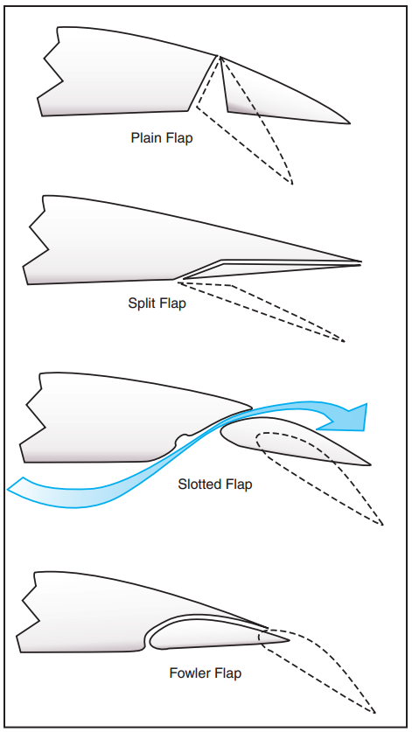
Fig.Four Basic Types of Flaps

Types of Trailing Edge Flaps:

Plain Flaps:

Plain flaps are the most common, but least efficient flap system

Attached on a hinged pivot, which allows the flap to the moved downward

The structure and function are comparable to the other control surfaces-ailerons, rudder, and elevator

When extended, it increases the chord line, angle of attack, and camber of the wing, which results in an increase in both lift and drag

It is important to remember that control surfaces are nothing more than plain flaps themselves

Split Flap:

Similar to the plain flap, but more complex

It is only the lower or underside portion of the wing

The deflection of the flap leaves the trailing edge of the wing undisturbed

It is more effective than the hinge flap because of greater lift and less pitching moment, but there is more drag

The split flap has significant drag at small deflections, whereas the hinge flap does not because airflow remains "attached" to the flap

Slotted Flap:

The slotted flap has greater lift than the hinge flap but less than the split flap; but, because of a higher lift-drag ratio, it gives better takeoff and climb performance

Small deflections of the slotted flap give a higher drag than the hinge flap but less than the split

This allows the slotted flap to be used for takeoff

A slotted flap will produce proportionally more lift than drag

Its design allows high-pressure air below the wing to be directed through a slot to flow over the upper surface of the flap delaying the airflow separation at higher angles of attack

This design lowers the stall speed significantly

Fowler Flap:

Most efficient design

Moves backward on first part of extension increasing lift with little drag; also utilizes a slotted design resulting in lower stall speeds and increased wing area

Creates the greatest change in pitching moment

Provides greatest increase in lift coefficient with the least change in drag

This flap can be multi-slotted making it the most complex of the trailing edge systems

Drag characteristics at small deflections are much like the slotted flap

Because of structural complexity and difficulty in sealing the slots, Fowler flaps are most commonly used on larger airplane

Blown Flap:

An aircraft with wing-mounted propellers, exhibits a blown flap effect

Provides extra airflow for wings by blowing air over the surfaces

Prevents boundary layer from stagnating, improving lift

At low speeds this system can "fool" the airplane into thinking it is flying faster

Can improve lift 2 or 3 times; however, the bleed air off the engine causes a decrease in thrust for phases of flight such as take off

Leading Edge Flaps:

Leading edge flaps increase stall margin

There are several types:

Slats:

Aerodynamic surfaces on the leading edge of the wings

When deployed, they allow the wing to operate at a higher angle of attack, so it can fly slower or take off and land in a shorter distance

Usually used while landing or performing maneuvers, which take the aircraft close to the stall, but are usually retracted in normal flight to minimize drag

Slats work by increasing the camber of the wing, and also by opening a small gap (the slot) between the slat and the wing leading edge, allowing a small amount of high-pressure air from the lower surface to reach the upper surface, where it helps postpone the stall

The chord of the slat is typically only a few percent of the wing chord

They may extend over the outer third of the wing or may cover the entire leading edge

The slat has a counterpart found in the wings of some birds, the Alula, a feather or group of feathers which the bird can extend under control of its "thumb"
- a) Explain the working principle of a simple hydraulic system with diagram.
BASIC HYDRAULIC SYSTEM
Each hydraulicsystem has a minimum number of basiccomponents through whichthe fluid is transmitted.
Hand Pump System
- The reservoir, stores the supply of hydraulic fluid for operation of the system.
- It fill the system fluid when needed, provides room for thermal expansion, and in some systems provides a means for bleeding air from the system.
- A pump is necessary to create a flow of fluid. The pump is hand operated.
- However, aircraft systems aremostly equipped with engine-driven or electric motor driven pumps.
- The selector valve is used to direct the flow of fluid. These valves are normally actuated by solenoids or manually operated, either directly or indirectlythrough use of mechanical linkage.
- An actuating cylinder converts fluid pressure into useful work by linear or reciprocating mechanical motion, whereas a motor converts fluid pressure into useful work by rotary mechanical motion.
- The flow of hydraulic fluid can be traced from the reservoir to the selector valve in figure 8-5.
- With the selector valve in the position shown, the hydraulic fluid flows through the selector valve to the right-hand end of the actuating cylinder.
- Fluid pressure then forces the piston to the left, and at the same time the fluid which is on the left side of the piston (figure 8-5) is forced out and back to the reservoir through the return line.
- When the selector valve is moved to the opposite position, the fluid from the pump flows to the left side of the actuating cylinder, thus reversing the process.
- Movement of the piston can be stopped at any time by moving the selector valve to neutral. In this position, all four ports are closed and pressure is trapped in both working lines.
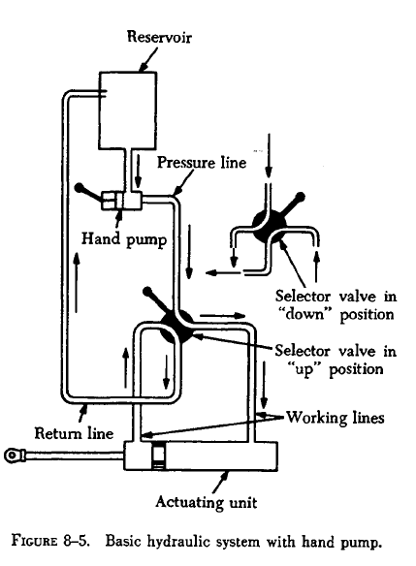
Power-Driven Pumps
Many of the power-driven hydraulic pumps ofcurrent aircraft are of variable-delivery, compensator-
Controlled type. There are some constantdelivery pumps in use. Principles of operation arethe same for both types of pumps.
- Constant-Delivery Pump
- A constant-delivery pump, forces a fixed or unvarying quantity of fluid through the outlet port during each revolution of the pump.
- Constant-delivery pumps are sometimes called constant-volume or fixed-delivery pumps.
- They deliver a fixed quantity of fluid per revolution, regardless of the pressure demands. Since the constant-delivery pump provides a fixed quantity of fluid during each revolution of the pump, the quantity of fluid delivered per minute will depend upon pump r.p.m.
- When a constant-delivery pump is used in a hydraulic system in which the pressure must be kept at a constant value, a pressure regulator is required.
- Variable-Delivery Pump
- A variable-delivery pump has a fluid output that is varied to meet the pressure demands of the system
by varying its fluid output.
- The pump output is changed automatically by a pump compensator within the pump.
Pressure Relief Valves
- A pressure relief valve is used to limit the amount of pressure being exerted on a confined liquid.
- This is necessary to prevent failure of components or rupture of hydraulic lines under excessive pressures.
- The pressure relief valve is a system safety valve.

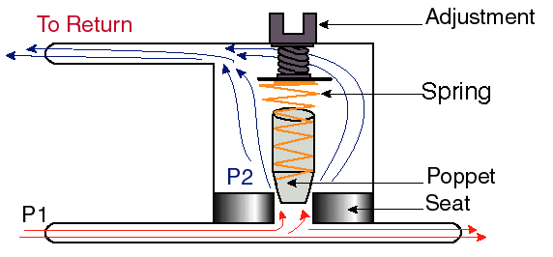
- The adjustment screw at the top of the pressure relief valve is set for a certain pressure value, let us call it P₂.
- In general, even with a pressure of P₁, the poppet would lift up, except that the spring is strong and has downward force forcing the poppet closed.
- Poppet will not move until a pressure greater than that required is felt by the system (i.e., P₁>P₂). When the pressure increases, the poppet will move up, forcing the excess liquid to move through opening at high velocity.
Accumulator
- The accumulator is a steel sphere divided into two chambers by a synthetic rubber diaphragm.
- The upper chamber contains fluid at system pressure, while the lower chamber is charged with air.
The function of an accumulator is to:
a. Dampen pressure surges in the hydraulicsystem caused by actuation of a unit and theeffort of the pump to maintain pressure at apreset level.
b. Aid or supplement the power pump whenseveral units are operating at once by supplyingextra power from its "accumulated"or stored power.
c. Store power for the limited operation of ahydraulic unit when the pump is not operating.
d. Supply fluid under pressure to compensatefor small internal or external (not desired)leaks which would cause the system to cyclecontinuously by action of the pressure switchescontinually "kicking in."
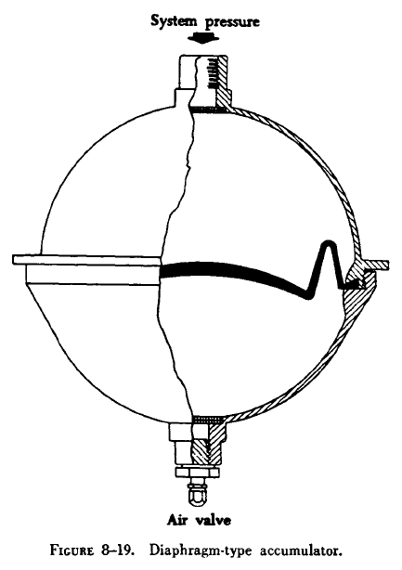

Check Valve:
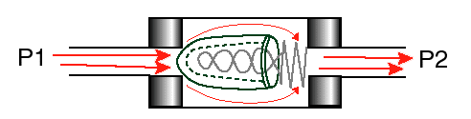
- Poppet type valve is the preferred type that is used in hydraulics now. The front of the poppet (left side of the picture above) sits tightly on the hard seat (darker shaded areas on the left side). The poppet works on the following principle.
- When high pressure fluid (with pressure P₁ ) comes in on the left, it forces the poppet open. Since P₁>P₂ , the force on the left side of the poppet (F₁) is greater than the force due to the spring (F₂ ) and is just enough to open the poppet.
- But, when flow stops, or there is a high pressure flow from the right side of the poppet, then P₂>P₁ and the pressure forces the poppet against the valve seat, closing off the opening. Thus the fluid is allowed to flow through in one direction only.Check valves are designed so as not to tolerate leakage. The purpose of the light spring is only to keep the poppet on the seat.
(OR)
b) Describe the principles of operation of the two types of shock absorbing landing gear
commonly used.

This shock absorber system is currently one of the most common in medium to large
aircraft, as it provides shock absorption as well as effective damping.
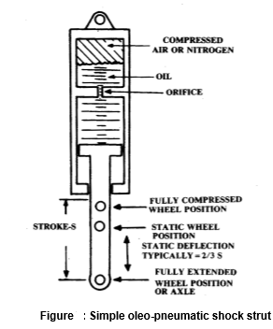
This type of shock absorber contains two integral components. The first is the compressed gaseous chamber that acts as a spring, absorbing the shock of the aircraft’s vertical movement. The second is the damping that acts by forcing hydraulic fluid through small holes (orifices), causing friction and thus slowing the oil. The integration of an oleo-pneumatic shock absorber into the landing gear system provides the most efficient shock absorption option.
There are three common configurations that implement the oleo shock absorber. These are telescopic strut, articulating strut and semi-articulating strut. The main difference between these three types of oleo shock absorbers is the positioning of the landing gear strut relative to the wheel and whether the shock absorber is structurally rigid with respect to the airframe.
Telescopic Strut
In a telescopic oleo strut arrangement, the shock absorber is positioned such that the shock absorber in housed within the main vertical strut of the landing gear. In this configuration the wheel deflects in the same line of action as the shock absorber as can be seen diagrammatically in Figure 8 below.
This arrangement has two distinct disadvantages. Firstly, when the shock absorber requires maintenance the entire landing gear system must be removed as the oleo-pneumatic shock absorber is housed within the main strut . Secondly, as the oleo-pneumatic shock absorber is positioned in a vertical fashion and connected directly to the wheels, the shock strut must be of adequate length to absorb the landing energy. This means that a relatively long, imposing oleo pneumatic shock strut is required.
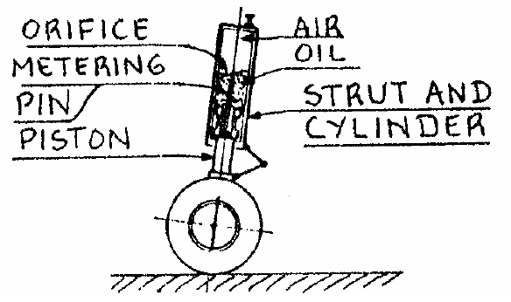
Articulating Strut
In an articulating oleo-pneumatic strut configuration, the oleopneumatic shock strut is the link between airframe and a linkage on which the wheel is connected. This configuration causes the wheel to deflect in a circular arc around the axis of rotation, as seen in Figure . This allows the wheel stroke length to be larger than the shock
absorber stroke due to the mechanical advantage of the linkage. The drawback, however, is that the oleo-pneumatic strut must carry a greater load. Notice also that during the travel of the wheel the shock strut moves with respect to the airframe, as the linkage moves about the pivot point.
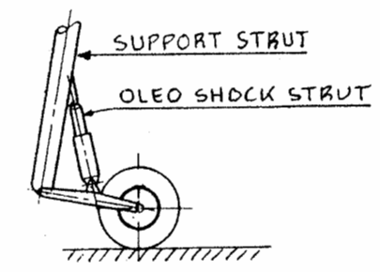

- a) With an aid of a diagram, describe the working principle of turbojet engine.
Working principles of Turbojet Engine
- The demand for increasing speed and size for the aircraft led to the use of gas turbine engines in place of reciprocating engines.
- The Thrust of the turbojet is developed by compressing the intake air in the inlet diffuser and then in the compressor, mixing the air with fuel and burning in the combustor and expanding the gas stream through the turbine and the exhaust nozzle.
- As the aircraft moves forward in the atmosphere, the atmospheric air enters the air intake, called the inlet diffuser.
- After initial compression in the diffuser, the air enters an adiabatic compressor
- A portion of the air after compression, directly enters the combustion chamber where fuel is added in the required propulsion.
- The fuel and air gets mixed and the combustion reaction takes place releasing heat energy.
- The flow through the combustion chamber is assumed to be steady and the heat addition is at constant pressure.
- The remainder of the compressed air is used to cool the chamber, and eventually all excess air is mixed with the products of combustion to cool to the required level before entering the turbine.
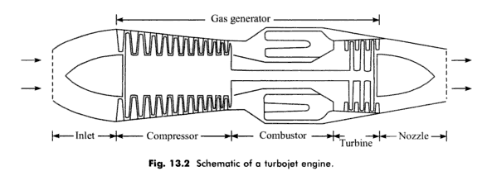
Intake Diffuser:
- The air inlet of the engine is employed to reduce the velocity of the entering air to a level suitable for entering the compressor without loss.
- The air velocity is reduced by diffusion (compression) processes which increases the air pressure.
Compressor:
- This function is further increase the pressure of the incoming air so that sufficient pressure can be achieved for expansion in the turbine and nozzle.
- By increasing the pressure, the size of the components; combustor and exhaust nozzle can also be reduced and the combustion process in the combustion chamber can be carried out efficiently.
- Centrifugal compressors are sometimes used in small gas turbine engines.
- In most of the present day aircraft gas turbine engines, split or two spool axial flow compressors are employed to attain higher pressure ratios of the order 10 to 15.
Combustion Chamber:
- In the combustion chamber, high pressure air leaving the compressor is burned with fuel at constant pressure.
- The combustor is usually designed to burn fuel with the air at an air fuel ratio of about 50 to 150.
- The combustor is designed to have maximum pressure loss with maximum combustion efficiency.
- In order to ignite the fuel air mixture, a high voltage electrical ignition system is employed.
Turbine:
- Turbine is located at the exit of the combustion chamber to extract some of the energy from the combustion products to power the compressor and other engine accessories.
- Nearly one fourth of the energy available in the products of combustion is required to drive the compressor.
- Axial flow multistage turbine is usually employed for this purpose.
- The two basic types of axial turbines used in propulsion engines are impulsion and reaction turbine.
- Most turbines in jet engines are a combination of impulse and reaction principles.
Exhaust Nozzle:
- In turbine engine, the hot gas after the expansion enters the exhaust nozzle in order to expand further to ambient pressure or less before getting discharged to the atmosphere.
- For low pressure ratio requirements, convergent nozzle is employed.
- For high pressure ratio requirements, a convergent-divergent nozzle is employed.
- The convergent-divergent nozzle employed in most of the supersonic aircrafts are of adjustable area type.
Thrust Augmentation:
- In order to increase the performance of turbojet engines during its take off, the thrust during take-off is usually augmented by adding an afterburner or by water injection.
- Thrust augmentation by water methanol injection is achieved by injecting a mixture of water and methanol into either the compressor inlet or combustion chamber.
- When injection is into the inlet of the compressor the intake air is cooled which results in an increased compressor pressure ration in addition to increased mass flow.
- The higher pressure and the increase in mass flow combine to increase the thrust.
Advantages:
- Highly suitable for higher speeds, higher altitudes and long distance to travel.
- The power to weight ratio is very high
- Simple and easy to maintain
- It require little lubrication
- Thrust developed by the turbojet engine can be increased by using afterburner when required
Disadvantages
- The fuel economy is very low at lower operational speeds and altitudes
- It is uneconomical for short distance flights

(OR)
b) Explain with the help of a sketch the operation of ‘booster coil’ in the ignition system.
The booster coil assembly, used mainly with older radial engine ignition systems, consists of two coils wound on a soft iron core, a set of contact points, and a condenser. The booster coil is separate from the magneto and can generate a series of sparks on its own. During the start cycle, these sparks are routed to the trailing finger on the distributor rotor and then to the appropriate cylinder ignition lead. The primary winding has one end grounded at the internal grounding strip and its other end connected to the moving contact point. The stationary contact is fitted with a terminal to which battery voltage is applied when the magneto switch is placed in the start position, or automatically applied when the starter is engaged. The secondary winding, which contains several times as many turns as the primary coil, has one end grounded at the internal grounding strip and the other terminated at a high-tension terminal. The high-tension terminal is connected to an electrode in the distributor by an ignition cable.
Since the regular distributor terminal is grounded through the primary or secondary coil of a high-tension magneto, the high-voltage furnished by the booster coil must be distributed by a separate circuit in the distributor rotor. This is accomplished by using two electrodes in one distributor rotor. The main electrode, or finger, carries the magneto output voltage; the auxiliary electrode or trailing finger, distributes only the output of the booster coil. The auxiliary electrode is always located so that it trails the main electrode, thus retarding the spark during the starting period.
In operation, battery voltage is applied to the positive (+) terminal of the booster coil through the start switch. This causes current to flow through the closed contact points to the primary coil and ground. The Current flow through the primary coil sets up a magnetic field about the coil that magnetizes the coil core. As the core is magnetized, it attracts the movable contact point, which is normally held against the stationary contact point by a spring.
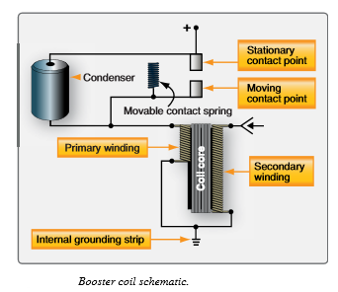
As the movable contact point is pulled toward the iron core, the primary circuit is broken, collapsing the magnetic field that extended about the coil core. Since the coil core acts as an electromagnet only when current flows in the primary coil, it loses its magnetism as soon as the primary coil circuit is broken. This permits the action of the spring to close the contact points and again complete the primary coil circuit. This demagnetizes the coil core, and again attracts the movable contact point, which again opens the primary coil circuit. This action causes the movable contact point to vibrate rapidly, as long as the start switch is held in the closed, or on, position. The result of this action is a continuously expanding and collapsing magnetic field that links the secondary coil of the booster coil. With several times as many turns in the secondary as in the primary, the induced voltage that results from lines of force linking the secondary is high enough to furnish ignition for the engine.
The condenser, which is connected across the contact points, has an important function in this circuit. As current flow in the primary coil is interrupted by the opening of the contact points, the high self-induced voltage that accompanies each collapse of the primary magnetic field surges into the condenser. Without a condenser, an arc would jump across the points with each collapse of the magnetic field. This would burn and pit the contact points and greatly reduce the voltage output of the booster coil. The booster coil generates a pulsating DC in the primary winding that induces a high-voltage spark in the secondary windings of the booster coil
- a) Explain the inspection and servicing of fire protection system.
Fire detector sensing elements are located in many high activity areas around aircraft engines. Their location, together with their small size, increases the chance of damage to the sensing elements during maintenance. An inspection and maintenance program for all types of continuous-loop systems should include the following visual checks. Sensing elements of a continuous-loop system should be inspected for the following:
1. Cracked or broken sections caused by crushing or squeezing between inspection plates, cowl panels, or engine components.
2. Abrasion caused by rubbing of the element on cowling, accessories, or structural members.
3. Pieces of safety wire, or other metal particles, that may short the spot-detector terminals.
4. Condition of rubber grommets in mounting clamps that may be softened from exposure to oils or hardened from excessive heat.
5. Dents and kinks in sensing element sections. Limits on the element diameter, acceptable dents and kinks, and degree of smoothness of tubing contour are specified by manufacturers. No attempt should be made to straighten any acceptable dent or kink, since stresses may be set up that could cause tubing failure.
6. Nuts at the end of the sensing elements should be inspected for tightness and safety wire. Loose nuts should be retorqued to the value specified by the manufacturer’s instructions. Some types of sensing element connection joints require the use of copper crush gaskets. These should be replaced any time a connection is separated. If shielded flexible leads are used, they should be inspected for fraying of the outer braid.
7. The braided sheath is made up of many fine metal strands woven into a protective covering surrounding the inner insulated wire. Continuous bending of the cable or rough treatment can break these fine wires, especially those near the connectors.
8. Sensing element routing and clamping should be inspected carefully. Long, unsupported
sections may permit excessive vibration that can cause breakage. The distance between clamps on straight runs, usually about 8 to 10 inches, is specified by each manufacturer.
9. At end connectors, the first support clamp usually is located about 4 to 6 inches from the end connector fittings. In most cases, a straight run of one inch is maintained from all connectors before a bend is started, and an optimum bend radius of 3 inches is normally adhered to. Interference between a cowl brace and a sensing element can cause rubbing. This interference may cause wear and short the sensing element.
10. Grommets should be installed on the sensing element so that both ends are centered on its clamp. The split end of the grommet should face the outside of the nearest bend. Clamps and grommets should fit the element snugly.
Fire Extinguisher System Maintenance
Regular maintenance of fire extinguisher systems typically includes such items as the inspection and servicing of fire extinguisher bottles (containers), removal and reinstallation of cartridge and discharge valves, testing of discharge tubing for leakage, and electrical wiring continuity tests. The following paragraphs contain details of some of the most typical maintenance procedures.
1.Container Pressure Check
Fire extinguisher containers are checked periodically to determine that the pressure is between the prescribed minimum and maximum limits. Changes of pressure with ambient temperatures must also fall within prescribed limits.
.2.Discharge Cartridges
The service life of fire extinguisher discharge cartridges is calculated from the manufacturer’s date stamp, which is usually placed on the face of the cartridge. The cartridge service life recommended by the manufacturer is usually in terms of years. Cartridges are available with a service life of 5 years or more. To determine the unexpired service life of a discharge cartridge, it is usually necessary to remove the electrical leads and discharge line from the plug body, which can then be removed from the extinguisher container.
3. Agent Containers
Care must be taken in the replacement of cartridge and discharge valves. Most new extinguisher containers are supplied with their cartridge and discharge valve disassembled. Before installation on the aircraft, the cartridge must be assembled properly in the discharge valve and the valve connected to the container, usually by means of a swivel nut that tightens against a packing ring gasket.
If a cartridge is removed from a discharge valve for any reason, it should not be used in another discharge valve assembly, since the distance the contact point protrudes may vary with each unit. Thus, continuity might not exist if a used plug that had been indented with a long contact point were installed in a discharge valve with a shorter contact point.

4. Fire Prevention
Leaking fuel, hydraulic, deicing, or lubricating fluids can be sources of fire in an aircraft. This condition should be noted and corrective action taken when inspecting aircraft systems. Minute pressure leaks of these fluids are particularly dangerous for they quickly produce an explosive atmospheric condition. Carefully inspect fuel tank installations for signs of external leaks. With integral fuel tanks, the external evidence may occur at some distance from where the fuel is actually escaping. Many hydraulic fluids are flammable and should not be permitted to accumulate in the structure.
Sound-proofing and lagging materials may become highly flammable if soaked with oil of any kind. Any leakage or spillage of flammable fluid in the vicinity of combustion heaters is a serious fire risk, particularly if any vapor is drawn into the heater and passes over the hot combustion chamber. Oxygen system equipment must be kept absolutely free from traces of oil or grease, since these substances spontaneously ignite when in contact with oxygen under pressure. Oxygen servicing cylinders should be clearly marked so they cannot be mistaken for cylinders containing air or nitrogen, as explosions have resulted from this error during maintenance operations.
(OR)
b) Describe the two basic methods used for ice detection system.
Pneumatic Deicing System
- In this system, air pressure for system operation is supplied by air bled from the engine compressor.
- The bleed air from the compressor is ducted to a pressure regulator.
- The regulator reduces the pressure of the turbine bleed air to the deicer system pressure.
- An ejector provides the vacuum necessary to keep the boots deflated.
- The air pressure and suction relief valves and regulators maintain the pneumatic system pressure and suction at the desired settings.
- The timer is essentially a series of switch circuits actuated successively by a solenoid-operated rotating step switch.
- The timer is energized when the deicing switch is placed in the "on" position.
- When the system is operated, the deicer port in the distributor valve is closed to vacuum and system operating pressure is applied to the deicers connected to that port.
- At the end of the inflation period the deicer pressure port is shut off, and air in the deicer flows overboard through the exhaust port.
- When the air flowing from the deicers reaches a low pressure (approximately 1 p.s.i.) , the exhaust port is closed.
- Vacuum is re-applied to exhaust the remaining air from the deicer.
- This cycle is repeated as long as the system is operating. If the system is turned off, the system timer automatically returns to its starting position.

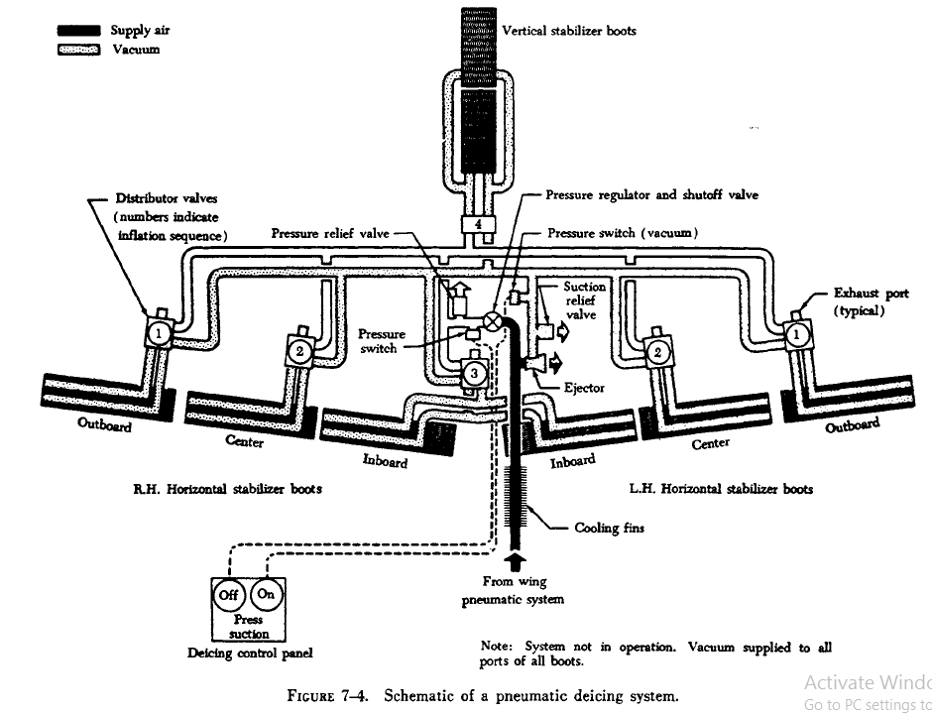
Anti-Icing Using Combustion Heaters
- Anti-icing systems using combustion heaters usually have a separate system for each wing and the empennage.
- A typical system of this type has the required number of· combustion heaters located in each wing and in the empennage.
- A system of ducting and valves controls the airflow.
- The anti-icing system is automatically controlled by overheat switches, thermal cycling switches, a balance control, and a duct pressure safety switch.
- The overheat and cycling switches allow the heaters to operate at periodic intervals, and they also stop heater operation completely if overheating occurs.
- The balance control is used to maintain equal heating in both wings.
- The duct pressure safety switch interrupts the heater ignition circuits if ram air pressure falls below a specified amount.
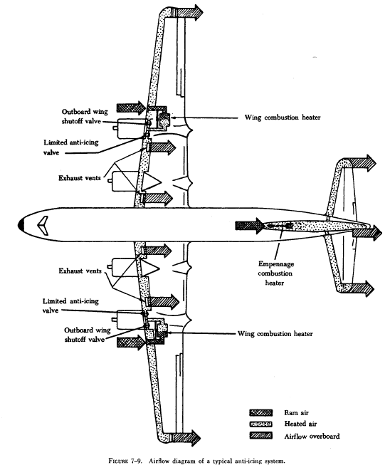
- a) Explain the operation of ‘mechanically operated Tachometer’ with sketch.

Tachometers
- The tachometer, or tach, is an instrument that indicates thespeed of the crankshaft of a reciprocating engine.
- Onreciprocating engines, the tach is used to monitor engine powerand to ensure the engine is operated within certified limits.
- Gas turbine engines also have tachometers. They are usedto monitor the speed(s) of the compressor section(s) ofthe engine.
- Turbine engine tachometers are calibratedin percentage of rpm with 100 percent corresponding tooptimum turbine speed.
- There are two types of tachometersystem in wide use today: mechanical and electrical.

Mechanical Tachometers
- Mechanical tachometer indicating systems are found on small, single-engine light aircraft.
- They consistof an indicator connected to the engine by a flexible driveshaft.
- The drive shaft is geared into the engine so that whenthe engine turns, so does the shaft.
- The indicator contains aflyweight assembly coupled to a gear mechanism that drivesa pointer.
- As the drive shaft rotates, centrifugal force actson the flyweights and moves them to an angular position.
- This angular position varies with the rpm of the engine.
- Theamount of movement of the flyweights is transmitted throughthe gear mechanism to the pointer.
- The pointer rotates toindicate this movement on the tachometer indicator, whichis directly related to the rpm of the engine.
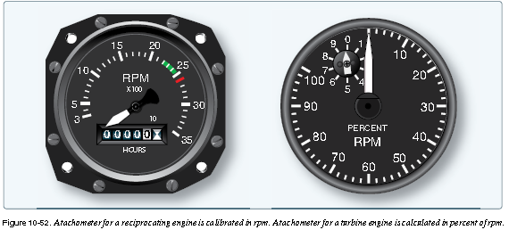
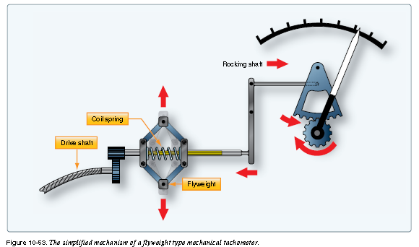
B. Tachometer Probes
- Some turbine engines use tachometer probes for rpmindication, rather than a tach generator system.
- They providea great advantage in that there are no moving parts.
- They aresealed units that are mounted on a flange and project intothe compressor section of the engine.
- A magnetic field is setup inside the probe that extends through pole pieces and outthe end of the probe.
- A rotating gear wheel, which movesat the same speed as the engine compressor shaft, alters themagnetic field flux density as it moves past the pole pieces atclose proximity.This generates voltage signals in coils insidethe probe.
(OR)
b) With the aid of the sketch, explain the working principle of accelerometer.
- An accelerometer is an instrument that measures acceleration. It is used to monitor the forces acting upon an airframe.
- Accelerometers are also used in inertial reference navigation systems. The installation of accelerometers is usually limited to high-performance and aerobatic aircraft.
- Simple accelerometers are mechanical, direct-reading instruments calibrated to indicate force in Gs. One G is equal to one times the force of gravity.
- The dial face of an accelerometer is scaled to show positive and negative forces.
- When an aircraft initiates a rapid climb, positive G force tends to push one back into one’s seat. Initiating a rapid decent causes a force in the opposite direction, resulting in a negative G force.
- Most accelerometers have three pointers.
- One is continuously indicating the acceleration force experienced.
- The other two contain ratcheting devices.
- The positive G pointer follows the continuous pointer and stay at the location on the dial where the maximum positive force is indicated.
- The negative G pointer does the same for negative forces experienced.
- Both max force pointers can be reset with a knob on the instrument face. The accelerometer operates on the principle of inertia. A mass, or weight, inside is free to slide along a shaft in response to the slightest acceleration force.
.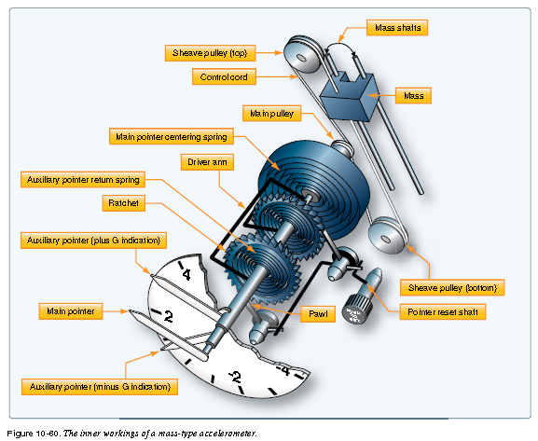
OR
15 b.

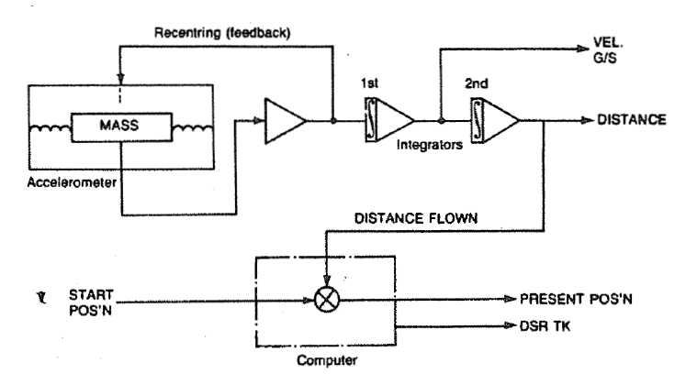
The operating principle is derived directly from the Newtonian laws of mechanics relating to velocity, acceleration and inertia. The relationships may be summarized as follows:
l. Velocity is the rate of change of displacement with respect to time for a moving object, and so is composed of both speed and direction. If the speed of an object is constant, but its direction is
changing, then its velocity changes.
2. A change in velocity, either in magnitude or direction of motion, is an acceleration (or deceleration). A body accelerates (or decelerates), i.e. changes its state of motion, only if it is acted upon by an external force.
3. AU matter tends to return to its existing state of motion and consequently resists any changes to that state; this property is known as inertia. The rate of acceleration of a body is proportional tp the
magnitude of its inertia. The inertial force displayed by a body under a given rate of acceleration gives a measure of the mass of that body. the mass of the unit is normally centred by two springs between two pick-off transformers.
When the aircraft accelerates, the mass is displaced, and a phase related signal is induced in the pick-off transformers. This signal is amplified. and is applied as feedback to the accelerometer via what is
termed a force generator, which consists of a coil which moves with the mass between the field of two permanent magnets. The effect of this device is to recentre the mass, and the current needed to achieve. This is, therefore, a measure of the acceleration. The use of this principle gives rise to the term 'force rebalancing accelerometer'.
The 'acceleration signal' is supplied to an integrator circuit which relates acceleration to time, and therefore produces a signal corresponding to ground speed (G/S). The G/S signal, in turn, is
supplied to a second integrator circuit which then produces a signal corresponding to distance flown. This double integration process solves the basic equation relating distance s travelled in a time t by a
body moving at a velocity v as given by:
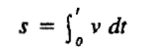 [1]
Since an input voltage (V;) is made proportional to the velocity of motion, and an output voltage (V0 ) is proportional to the distance travelled, then in terms of electrical integration, equation [I]
becomes:
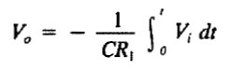
The product CR1 is referred to as the time constant of the circuit. If the 'distance flown' signal is then applied to a point within the computer, and summed with one corresponding to the aircraft's
starting point, the result is a signal which gives the aircraft's present position. If the latter together with the desired track (DSR TK) are known, the computer can develop steering commands to keep the
aircraft on the DSR TK /iO that it can reach any desired destination.

